
CYBERSECURITY W-1
INTERNSHIP REPORT TASK 1
Dua Eman | 4/29/26 | CYBERSECURITY

Week 1 Security Assessment Report
Name: Dua Eman
Role: Cybersecurity Intern
Organization: Developer Hub Corporation

1. Introduction
This report presents the Week 1 security assessment of a vulnerable Node.js web application. The objective was to set up the application locally, perform basic vulnerability testing, and identify common security weaknesses using manual testing and OWASP ZAP. The assessment focused on login functionality, user input handling, and security misconfigurations.

2. Application Setup
A vulnerable Node.js web application was downloaded from GitHub and configured on a Windows 10 Lenovo ThinkPad X260 system.

Tools Installed:
- Node.js
- Visual Studio Code
- OWASP ZAP

Setup Steps:
- Installed Node.js and npm.
- Downloaded vulnerable Node.js application from GitHub.
- Extracted project files to local drive.
- Ran npm install to install dependencies.
- Started the application using npm start.
- Accessed the application at: http://localhost:3000

3. Testing Performed

Manual Testing

Login Testing
- Tested empty username/password fields.
- Application displayed validation message requiring all fields.
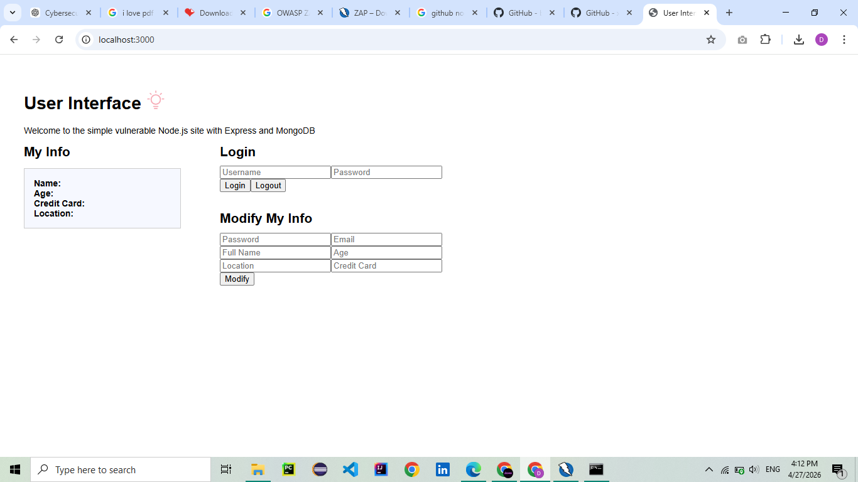
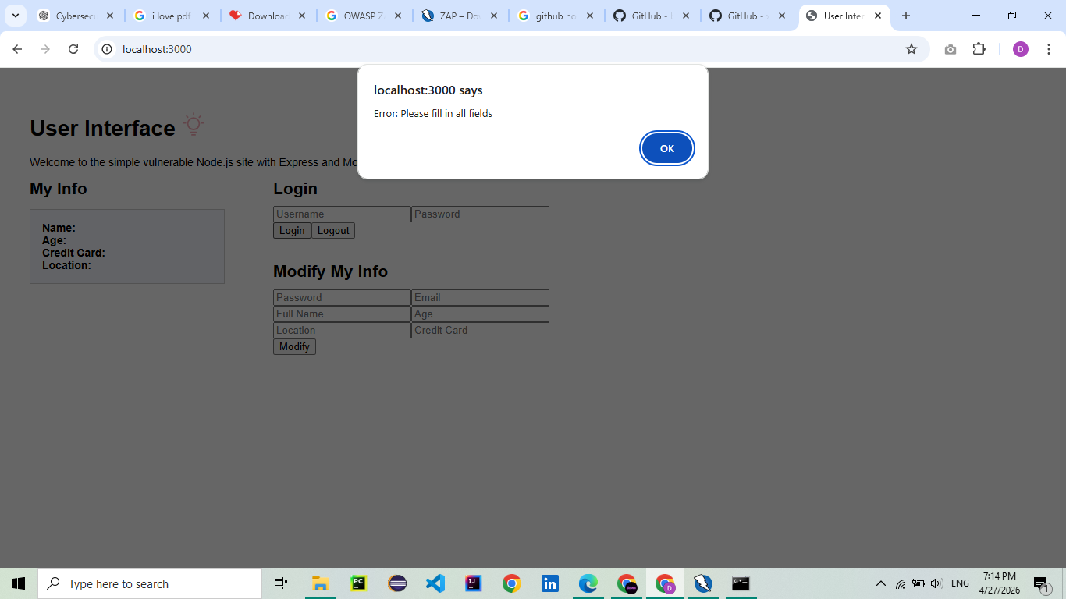

SQL Injection Testing
Entered the following payload in login fields:
admin' OR '1'='1
Result:
- No authentication bypass observed.
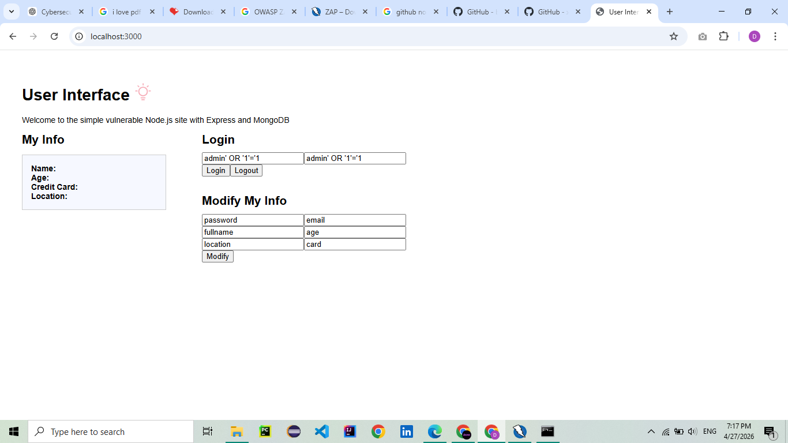

Cross-Site Scripting (XSS) Testing
Inserted script payload in form fields:
Result:
- No popup triggered through application fields.
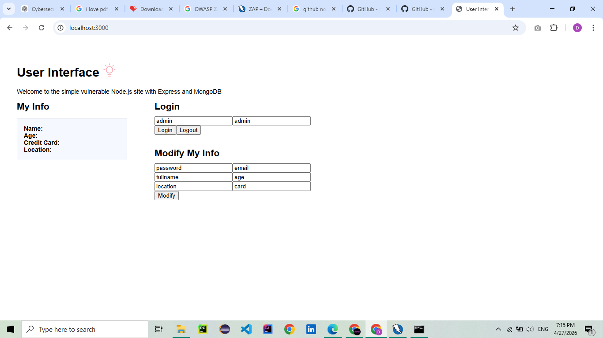

Browser Developer Tools Testing
Used Chrome Developer Console and executed:
alert('XSS Test')
Result:
- JavaScript executed successfully in the browser console.
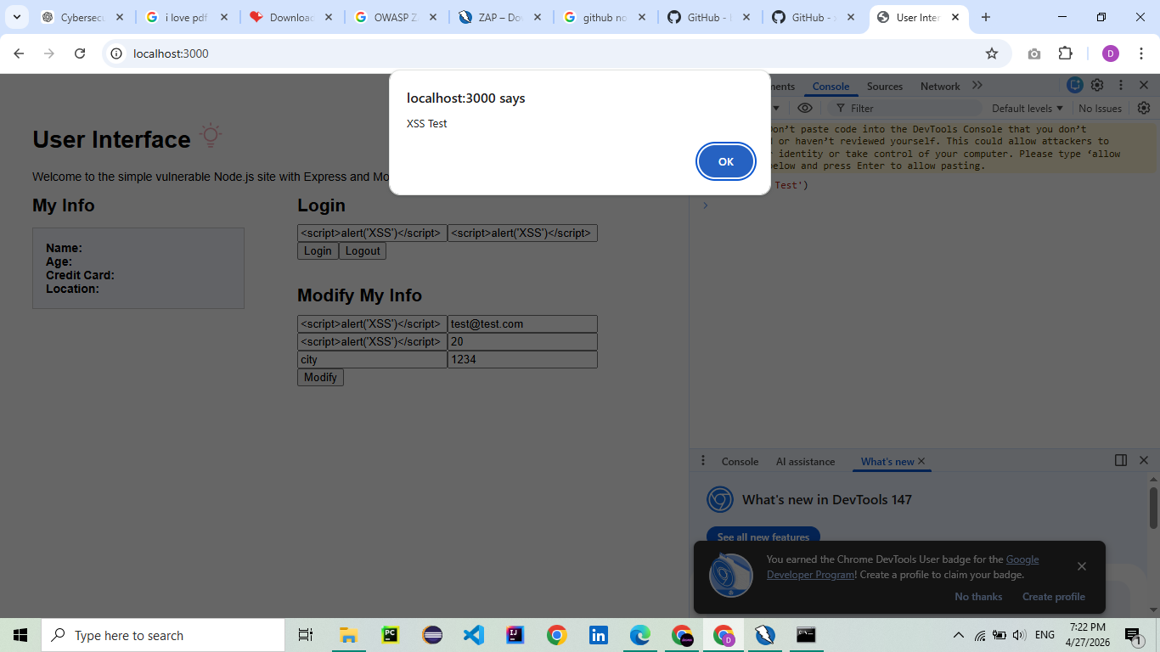
alert('XSS Test')

Automated Vulnerability Scan
OWASP ZAP was used to scan:
http://localhost:3000
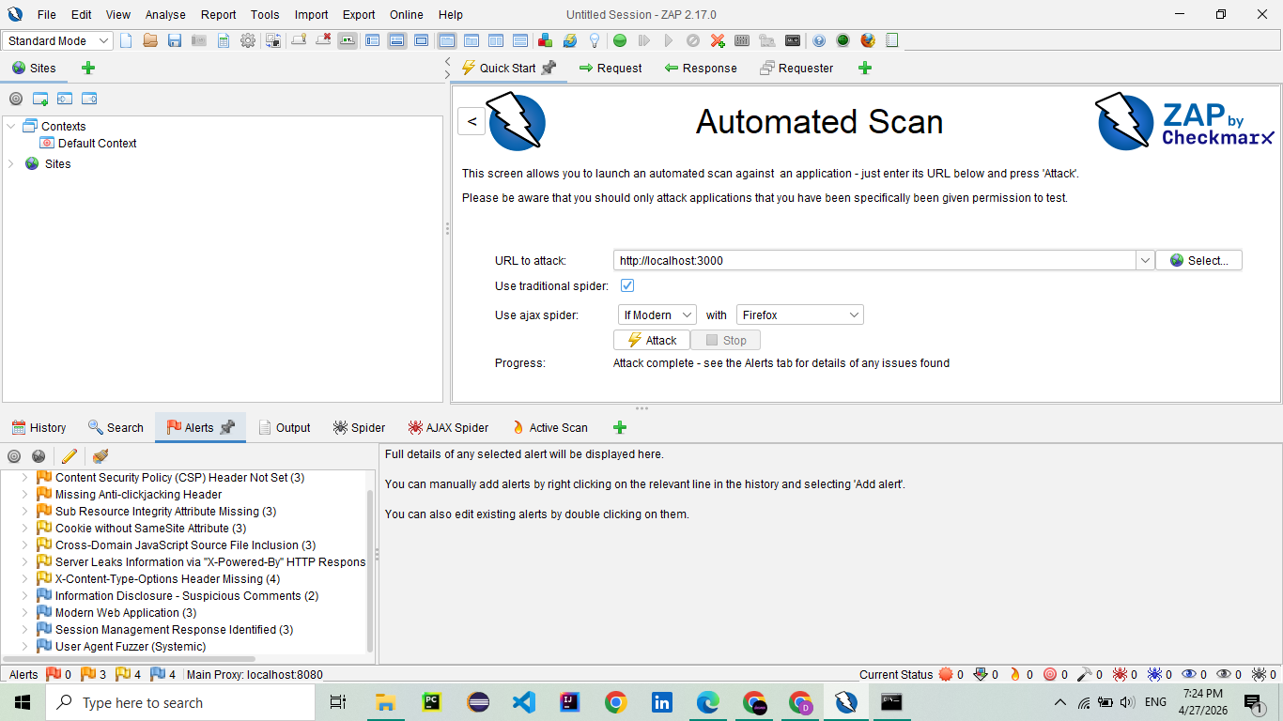

4. Vulnerabilities Found
OWASP ZAP identified the following issues:

Medium Severity
- Content Security Policy (CSP) Header Not Set
- Missing Anti-clickjacking Header
- Cookie without SameSite Attribute

Low Severity
- Sub Resource Integrity Attribute Missing
- Cross-Domain JavaScript Source File Inclusion
- Server Leaks Information via X-Powered-By Header
- X-Content-Type-Options Header Missing

Informational
- Session Management Response Identified
- Modern Web Application Detected
- Additional minor informational findings.

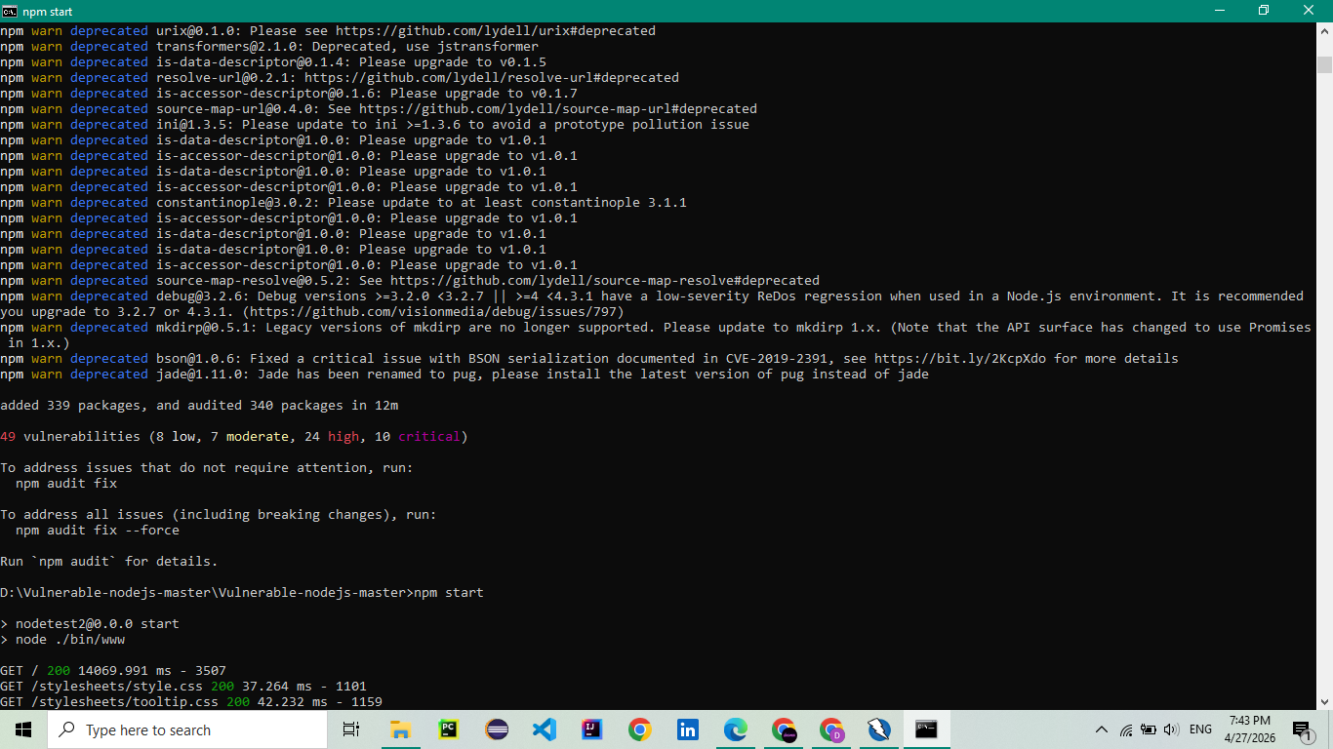

5. Recommendations
- Implement Content Security Policy headers.
- Add X-Frame-Options or frame-ancestors header to prevent clickjacking.
- Set cookies with SameSite, Secure, and HttpOnly flags.
- Hide server technology headers such as X-Powered-By.
- Add X-Content-Type-Options: nosniff header.
- Validate and sanitize all user input.
- Use parameterized queries to prevent SQL Injection.
- Use secure password hashing such as bcrypt.
- Perform regular vulnerability scanning.

6. Conclusion
The security assessment successfully identified several security misconfigurations and potential weaknesses in the web application. Manual testing and OWASP ZAP scanning provided practical understanding of common web vulnerabilities. Applying the recommended fixes will significantly improve the security posture of the application.

